SmartCare v0.3 - Domain Model Workbook
Week 6 student resource

Requirement-to-Concept Trace

Requirement | Concept | State/behaviour | Decision
FR-01: Register new patients | Patient, Receptionist | Patient.name, Patient.dateOfBirth, Patient.medicalHistory  Behavior: Receptionist.createPatientRecord() (make new instance) | Accepted
FR- 2, 8: View and modify practitioner availability | Practitioner, TimeSlot, Receptionist | State: Practitioner.specialty, TimeSlot.status, TimeSlot.startTime, TimeSlot.endTime  Behavior:  TimeSlot.add(), TimeSlot.update(),  TimeSlot.checkAvb() | Accepted
FR- 3, 4, 5, 7 : Book, modify, cancel, persist appointment. (Manage duplicate appointments) | Appointment, Receptionist, Patient, Practitioner, TimeSlot | State:  Appointment.id,  Appointment.patient_id,  Appointment.practitioner_id,  Appointment.TimeSlot,  Appointment.Status  Behavior:  Appointment.book,  Appointment.update(),  Appointment.cancel(),  Appointment.getDetails(),  Appointment.checkConflict() | Accepted (Database class for persistence is rejected though)

CRC Cards

Not using TimeSlots class for now, for the sake of simplicity and assignment instructions.

Patient
Responsibilities | Collaborators
Maintain their State/ (identity and Data). | Receptionist
Validate their appointments and data. | Appointment

Practitioner
Responsibilities | Collaborators
Maintain their identity, data like speciality etc. Maintain their appointments, availability and schedule. | Appointments

Appointment
Responsibilities | Collaborators
Scheduled Date and Time, Maintain consistent status, and maintain consistent state according to the status (for eg. if status is cancelled then the actual record should be cancelled and removed from schedules too)  Maintain accurate patient and practitioner ids/mappings | Patient, Practitioners and Receptionist

Receptionist
Responsibilities | Collaborators
Register Patient / Create Maintain Patient Records | Patient
Create, Maintain Practitioner record, view schedules/avb. | Practitioner
Manage Appointment Bookings. | Appointments.

Note: Receptionist does have a bit of tight coupling, but it is defensible for our system because almost all responsibilities reside with the receptionist/admin/clinicstaff, so they act as a gateway to the whole system.

UML Class Diagram
Insert/draw UML here. Include defensible relationships and multiplicities.

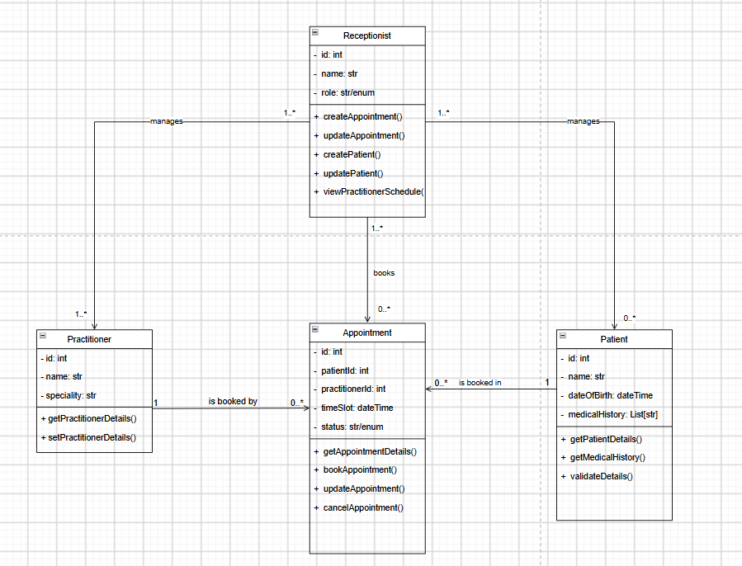

Design Rationale
Explain class selection, responsibility allocation and key relationships.
Class Selection & Responsibility Allocation:
Patient: Main domain entity required by the system. Patient has identity (ID, name, dateOfBirth) and medicalHistory. Must be a class to model patient data, maintain its instance’s state and validate information. Rationale: Patient owns its state; Receptionist calls Patient methods to update, receptionist creates/registers new patients by probably making new instance.
Practitioner: Again a main domain entity required by system. Practitioner maintains own identity (ID, name, specialty) and manages availability/schedule. Practitioners are responsible for their own professional data and schedule, not the system managing it for them.
Appointment: Again a major entity, for which the whole system is designed in the first place. Connecting Patient and Practitioner. Appointment maintains dateTime, status, and (patientID, practitionerID FKs). Status consistency (booked/confirmed→ cancelled/completed) is critical business logic, status change must cascade (e.g., cancelled appointment removed from Practitioner's schedule).
Receptionist: They are operational staff role. Required by system context that they are central entity in real-world managing everything. Receptionist performs CRUD operations on behalf of Patient, Practitioners and Appointment entities.
Key Relationships:
Patient -> Appointment (1-to-Many) because, one patient can have zero or more appointments over time. Appointment holds patientId as FK, Patient can retrieve appointment history via service/repo layer.
Practitioner -> Appointment (1-to-Many) because one practitioner can be booked in zero or more appointments over time. Appointment holds practitionerID as FK, practitioners can retrieve appointment history via service/repo layer.
(With my optional Class)
Receptionist -> Appointment (Many to Many) because one or many different receptionists/staffs can manage the same appointments/zero or more appointments. And any receptionist staff can book and manage many appointments. So many staff can manage many appointments.
Receptionist -> Patient (Many to Many) because one or many receptionist can maintain, and manage (CRUD) for many patient records.
Receptionist -> Practitioner (Many to Many) because one or many receptionists can maintain, and manage (CRUD) for many practitioner records.

AI Design Review Record
(Note: I have excluded those suggestions that are already part of our model, like Practitioner, patient and Appointments. - Its not clear from the assignment instructions whether we should consider it.) If these were to be considered, it would go in accepted state with its requirement evidence, and Receptionist class in Modified and Accepted state, the rest classes in rejected state.)
AI suggestion | Evidence | Decision | Reason | Model change
ClinicStaff (Receptionist) Class and its Relationships | Supporting Requirements: FR-01, FR-03, FR-04, FR-06, FR-07, FR-09, NFR-04  (These call for receptionist to manage and maintain patient/practitioner records) | Accepted (a bit of modifications too.) | Critical role in the real-world system, everything is managed (system is run by) receptionist. Our one of the primary user. | New class added, new relationships added to the model.
TimeSlot and its relationships (except the relationships with Schedule, since schedule is just a fancy collection of timeslots, not needed) | FR- 3, 4, 5, 7 : Book, modify, cancel, persist appointment. (Manage duplicate appointments) | Modified (Rejected now for the basis of simplicity) | Just for simplicity, we can assume that every appointment lasts for 1 hour slot from its starting time, hence we dont need a separate class to manage. We can work with DateTime. | No change to the model since we wont be continuing with this. As it is not allowed in the assignment conditions, and we will use basic assumptions for simplicity.
Clinic Class | FR-2, 3, 4, 8  View availabilities, maintain data, search for patient info practitioner info etc. | Rejected (can accept with modification the assignment didnt allow us for an additional class on top of a receptionist one.) | Can be used for collection of patient/practitioners and availabilities, to search from. However, with separation of concerns in real world system, it would be the concern of Patient service/repo classes respectively for their searching and so on for practitioner). | No change to model.
The rest of the suggestions. | Low evidence. | Rejected. | No concrete evidence, for manager and scheduler classes. | No change to the model.

